HERO STEELS LIMITED
Cold Rolling Steel Plant · Digital Transformation Initiative

MODULE M1 — DATA CAPTURE LAYER
M1-09 · Document 10 of 10
Reporting & Monitoring
Role-based dashboards and KPI definitions — production, OEE, downtime, yield, rejections, traceability, quality and shift performance
Document set — M1 Technical Blueprint
Doc | Title
M1-00 | Blueprint Overview & Index
M1-01 | System Architecture
M1-02 | Process-Wise Data Capture Design
M1-03 | UX Design & Operator Workflow
M1-04 | Data Model & Database Design
M1-05 | Role-Based Access Control & Security
M1-06 | Planning Integration & Export
M1-07 | Validation Framework
M1-08 | Audit Trail & Compliance
M1-09 | Reporting & Monitoring
Prepared for Z Company · Role: Manufacturing Digital Transformation Consultant / Industrial Software Architect
Version 1.0 · 30 May 2026 · Confidential

Contents

1. Reporting Approach
Because M1 captures clean, structured data at source, reporting is a read concern — no re-keying, no spreadsheet stitching. All dashboards read from the BI replica so analytics never competes with capture. Each role sees a dashboard scoped to its responsibility and access (M1-05): the operator sees their shift, the supervisor their lines, the plant head and management the whole plant. Every KPI tile drills down to the underlying coils, so a number is never a dead end.
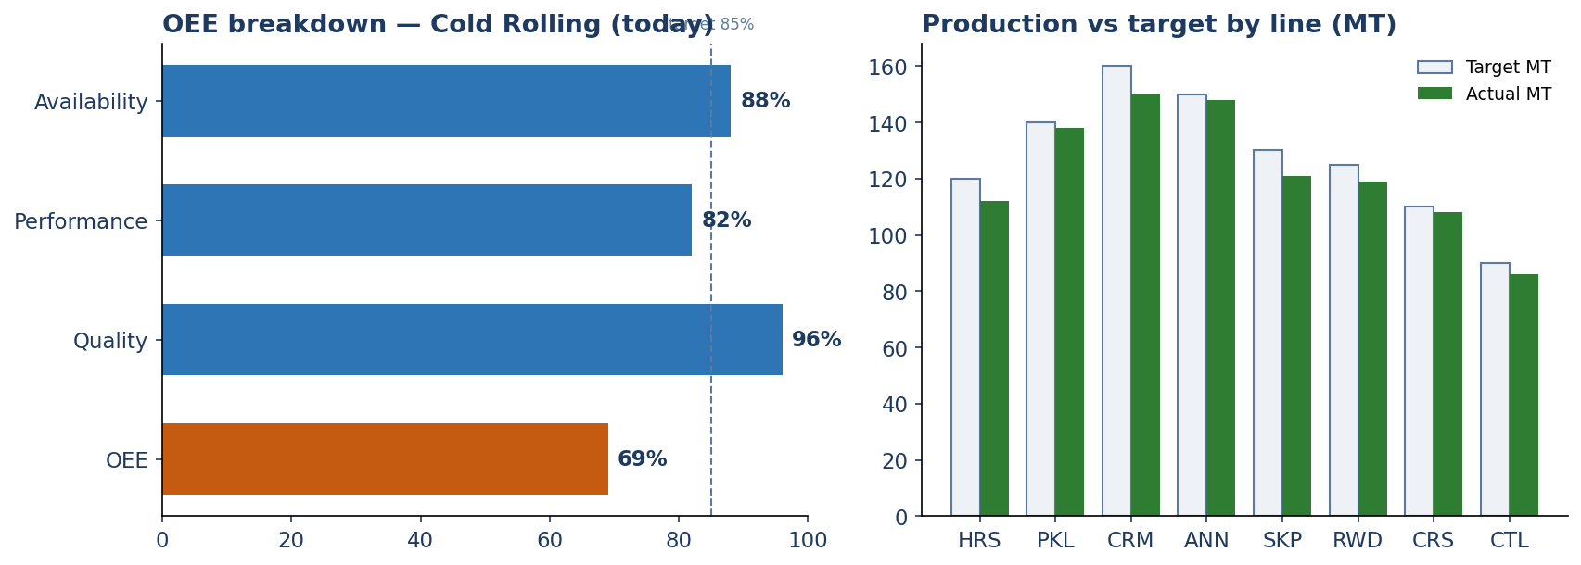
Figure. Illustrative supervisor view — OEE breakdown and production vs target

2. Dashboards by Role

2.1 Operator dashboard
- Target vs produced for the current shift; open vs done coils.
- Running stoppage timer and today's stoppage tally; missed chart slots (Pickling) flagged.
- Personal/line pace; next planned coils queued.
- Purpose: keep the operator on pace and nothing forgotten — not analysis.

2.2 Supervisor dashboard
- Multi-line shift status; entries pending review/approval.
- Line OEE, downtime Pareto (by stoppage code), yield and rejection rate.
- Holds and exceptions needing a decision; validation overrides used.
- Purpose: run the shift and assure data quality across owned lines.

2.3 Plant Head dashboard
- Plant-wide OEE and trend; production vs plan by line, grade, customer.
- Quality trends and top defects; downtime drivers; yield and scrap trends.
- Coil traceability search across all lines.
- Purpose: oversight and prioritisation — read and analyse, no capture.

2.4 Management dashboard
- Executive KPI summary: throughput, OEE, on-time vs plan, rejection cost, trend vs target.
- Period comparisons (shift/day/week/month); export for board reporting (interim, M1-06).
- Purpose: strategic view of plant performance.

3. Core KPIs & Definitions
All KPIs derive from M1 capture — no separate data entry. Definitions are fixed plant-wide so a number means the same thing on every screen.
KPI | Definition | Built from
Production tracking | Produced MT vs target, by shift/line/grade/customer | shift_log.target, prod_* weights
OEE | Availability × Performance × Quality | run time vs stoppages; rate vs ideal; good vs total
Availability | Run time ÷ planned time (1 − downtime share) | stoppage_entry durations vs shift length
Performance | Actual rate ÷ ideal rate | produced vs time taken vs line standard
Quality rate | Good output ÷ total output | weight minus rejection/scrap/hold
Downtime | Total & by reason (Pareto) | stoppage_entry grouped by stoppage_code/category
Yield | Good output ÷ input (1 − scrap%) | input weight vs good weight; scrap_mt
Rejections | Rejection MT & rate; OD/ID split at CRS | rejection_mt, rejection_od/id_mt
Coil traceability | Full forward/backward genealogy of any coil | coil_process_history, parent/child, charge grouping
Quality trends | Hardness/UTS/elongation/roughness vs spec over time | prod_crm / prod_crs vs grade_spec
Shift performance | Output, OEE, downtime, rejections by shift & crew | shift_log, crew_entry, prod_*

4. Standard Reports
- Daily production report — by line and shift, vs plan, with yield and rejection.
- Downtime / stoppage analysis — Pareto by reason and category, by line and period.
- Quality report — properties vs spec, defect frequency, complaint root-cause via traceability.
- Coil genealogy report — the full history of a coil for customer audits (M1-08).
- Shift handover report — produced vs target, open coils and holds carried forward.
- Plan-vs-actual — fulfilment against the PP&C/SAP plan, feeding the planning loop (M1-06).

5. Monitoring & Alerts
Signal | Who sees it | Trigger
Behind target | Operator, Supervisor | Produced vs pace falls below threshold
Extended stoppage | Supervisor | A stoppage exceeds its expected duration
Missed chart slot | Operator, Supervisor | Pickling hourly slot not entered
Out-of-spec quality | Supervisor, Plant Head | Measured property breaches grade/customer spec
Rejection spike | Supervisor, Plant Head | Rejection rate above rolling baseline
Pending approvals | Supervisor | Submitted shift logs awaiting review

6. Scalability & Modularity of Reporting
- Dashboards read the replica; heavy queries never slow capture, and reporting scales by adding replicas.
- KPIs are computed from canonical fields, so a new line or field appears in analytics automatically once captured.
- Reporting is a separate service consuming the same data other modules will use — M2 (quality/SPC) and M3 (OEE) extend rather than replace it.
- Definitions live in one semantic layer, so every dashboard, export and module shares identical KPI maths.
- Live, self-refreshing views can be published for shop-floor and management screens without bespoke builds.
From capture to insight, no detour
Every KPI in this document is a direct read over M1 capture. There is no parallel reporting database to reconcile — the system of record and the analytics source are the same data, separated only for performance.

